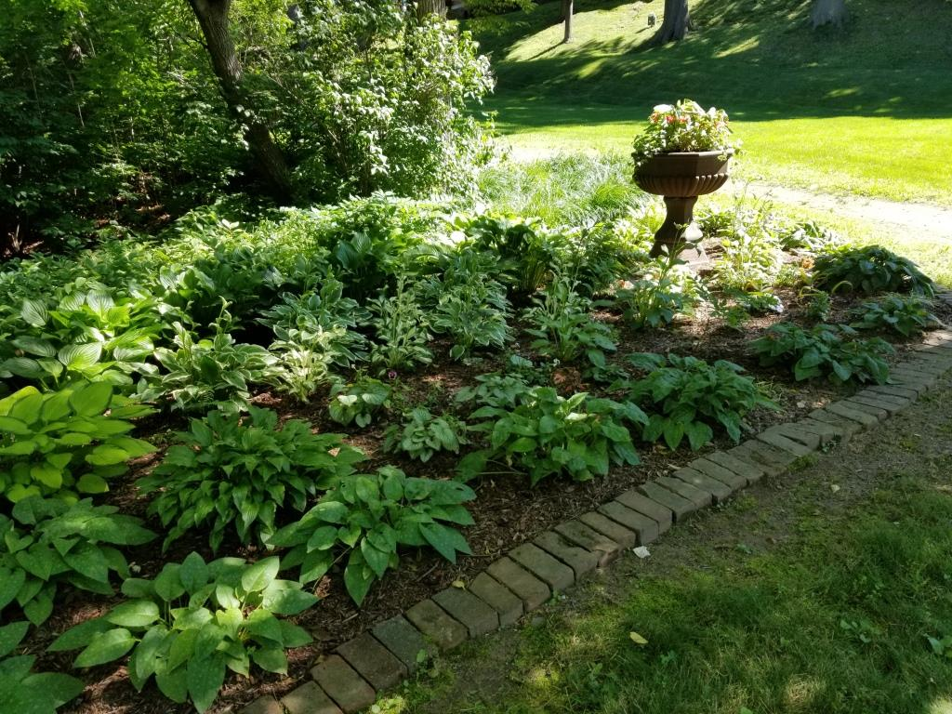A BRIEF GUIDE TO THE PLANTINGS
IN THE MARK TWAIN HOUSE GROUNDS AND THE CONSERVATORY

September 2019
For more than a decade, University of Connecticut Master Gardeners have worked with the plantings and landscaping on the Mark Twain House grounds, most recently under the direction of Christie Kuriger, the museum’s Gardens and Ground Coordinator. Christie combines a staggering amount of horticultural skill with an artist’s eye, and creatively incorporates historical hints and tributes into her and her volunteers’ skilled, difficult and consistent good work. At the same time, the quiet, longtime work of Master Gardener Marianne Cassidy and her crew in the Conservatory has continued, keeping the plantings there up to date. The brief guide below has been put together by Steve Courtney, with the help of Christie and Marianne, in response to interpreter interest in being able to explain some of the plantings to visitors. Both Christie (christiekuriger@gmail.com) and Marianne (nanacass@mac.com) look forward to any questions you might have about their work.
The 1997 Historic Landscape Report for the Mark Twain House provides little information on what plantings there were around the house and Carriage House. However, Livy gave gardener Daniel Molloy a horticultural book (Peter Henderson’s Practical Floriculture) in 1883 which survives. Molloy marked up this book in ways that give us some evidence of what might have been planted. Because the Clemenses spent most of their Hartford summers in Elmira, there were not extensive plantings, and many of the plants marked in the book are greenhouse plants, grown there to decorate the house. (When we set the table for Susy’s 16th birthday in 1888, for example, we decorate it with nasturtiums, basing this on a guest’s letter. These flowers would have been far out of season in March.)
Molloy’s book does contain markings for balsam, amaranths, zinnias, lobelia, and salvia, which are plants not normally forced in a greenhouse. “These plants could have been used in a bedding scheme in the carriage turnway or a cutting garden or both,” says the Landscape Report. The report also points out that these annuals are at their best in late summer, which would work historically – that was when the Clemenses returned from Elmira.
1. THE OUTDOOR GARDENS
The Urn Garden
Though not along the path of the standard tour, the first garden visitors encounter after leaving their cars is the “urn” garden (shown above), characterized by a flourishing bed of shade-friendly hosta and the urn itself, home to a changing array of plants. In late spring of 2019, it contained red begonias – red being, according to tradition, Sam’s favorite color. Pansies nearby evoke a more solemn reference: A surviving dress of Livy’s – possibly worn for an anniversary of little Langdon’s death – was black with a pansy motif, pansies being a symbol of remembrance. On a lighter note, in The Adventures of Tom Sawyer, a flirtatious Becky Thatcher tosses a pansy to Tom.

In the urn: Dracaena, red dragon wing begonias, coleus, and vinca vine. In the garden: ferns, hosta, wild ginger, coral bells, bleeding hearts, pulmonaria, bruneria, Solomon’s seal, coleus, hyacinth, tête-a-tête daffodils, crocus and grape hyacinth bulbs, and pansies.

The Visitors Center Stairs and Path
To the left as you face the VC stairs, you’ll find boxwood, a Victorian-era staple, in a planter, and behind it in a brick-lined garden are red-twig dogwood shrubs. Their scarlet branches add color even in the dead of winter, while their variegated leaves stand out in summer. To the right, at the foot of the paved path, sedum and variegated lariope, an ornamental grass, have been planted. The borders of the path itself are a work in progress; Christie has a plan afoot to plant ostrich ferns for visitors to admire from the windows of the café. But the winding trail that makes the museum more accessible also evokes the paths that led through the Nook Farm woods south from the Carriage House in the Clemenses’ day – paths the family followed to visit neighbors.
Stairway planters: Boxwood, sweet potato vine, lantana, cabracola (mini petunias) and red dracaena. Stairway garden: Red twig dogwoods-lovely red stems in the winter and variegated leaves in the summer. The path: Shade- loving plants such as ivy, ferns, pulmonaria, and soon-to-be-added hostas and daffodil bulbs.

The Fran Gordon Garden
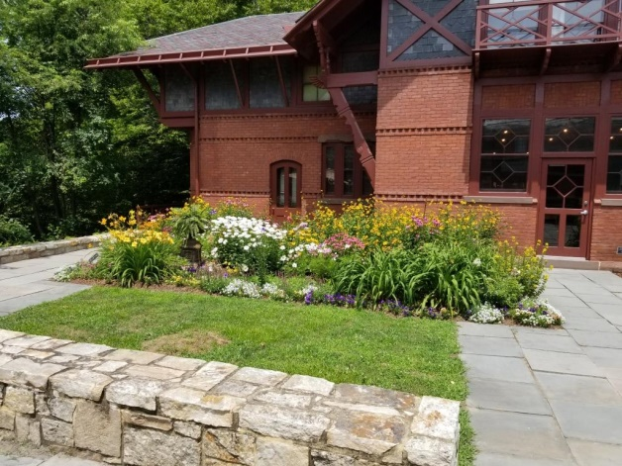
On the standard tour we pause on the patio to take in the Carriage House, but during the growing season the Fran Gordon Garden steals the show in the foreground. The garden honors Frances Gordon (1924-2014), a dynamic, funny and brilliant woman who loved Hartford and made the Mark Twain House her business, garnering support and volunteers in the 1960s and 1970s and founding the Friends of The Mark Twain House & Museum. The garden was relocated and rededicated in 2018.

Perennial sunflowers, coneflowers, butterfly weed, vintage daylilies, huckleberry candy daylily (reference obvious!), anise hyssop, zinnias, cosmos, snapdragons, pansies, alyssum, pink veronica, spider plants, yarrow, Shasta daisies, sedum, tree peony and iris. The urn, donated by Gail and Ed Thibodeau, contains seasonal plants.

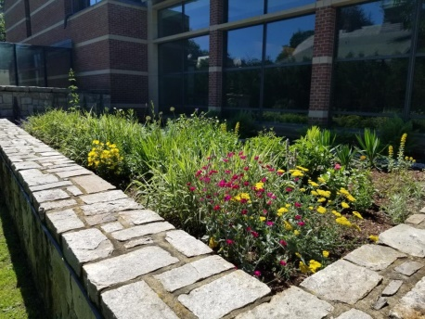.
The Rooftop Garden
The garden on the roof above the VC stairs is surrounded by a stone wall and raised slightly above the level of the adjacent patio. It is a “pollination garden,” designed to attract bees and butterflies. (“It was Maeterlinck who introduced me to the bee,” writes Mark, speaking of the author of The Life of the Bee. “I mean, in the psychical and in the poetic way. I had had a business introduction earlier.”) Along with its pollination role, “it’s also, truly, a Friendship Garden,” says Christie, given the number of plants from friends’ and volunteers’ gardens that she has gratefully received. A sundial donated by volunteer Cindy Curry provides visual interest.
Yarrow, perennial and annual Sunflowers, yucca, yellow loosestrife, Joe Pye weed, baptisia, lemon balm, variegated grasses, iris, rose campion, asters, phlox, coreopsis, allium, Asiatic lilies, anise hyssop, Shasta daisies, pansies, Stella D’Oro daylilies and castor beans.

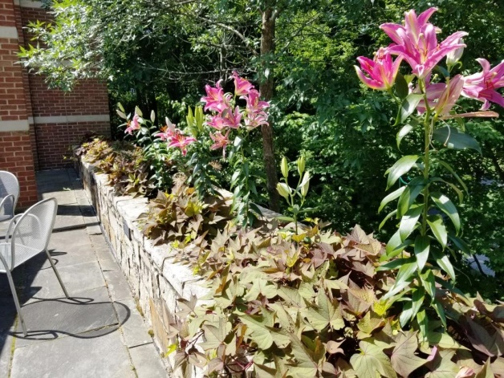

The Wall Garden

The wall above the Visitors Center entrance provides a raised, narrow garden that is designed to survive with a lower level of maintenance. And yes, when volunteers close the garden down in the fall, they have found sweet potatoes.

Sweet potato vines, Asiatic lilies, allium, hyacinth, daffodils, and coleus.

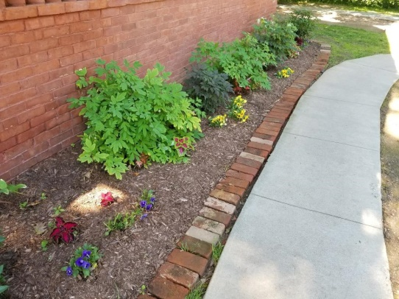

The Carriage House Garden

Tucked along the north side of the Carriage House, this garden contains shade-loving and shade-tolerant plants that are historically correct for the Victorian period.

Native mountain laurel, bleeding hearts, coleus, pansies, and cimicifuga (snake plant or black cohosh).

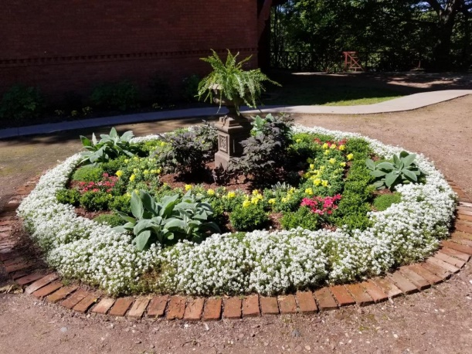

The Turnway Garden

The plantings at the center of the curved drive where, in Mark Twain’s day, carriages and sleighs turned around to return to Farmington Avenue, are on the site of one of the best-documented gardens kept by the Clemenses. In an autobiographical dictation in 1906, Clemens described the driveway: “This was a single road, and was like a spoon whose handle stretched from the gate to a great round flower-bed in the neighborhood of the stable. At the approach to the flower-bed the road divided and circumnavigated it, making a loop.” This garden is today historically correct, not only in being made up of plants popular in that era, but also in following Victorian design principles. The plantings are in a geometric form, following the precepts of prominent garden designer Beatrix Farrand (1872-1959). (The famed Sunken Garden at Farmington’s Hill-Stead Museum is her work.)

Boxwoods, rose campion, lamb’s ear, thyme, alyssum, pinks, snapdragons, cimicifuga (snake plant or black cohosh) and pansies in the spring. This garden is funded by the generosity of Gail and Ed Thibodeau with the goal of creating a “historically correct” garden. Research was done by Gail, Ed, Cindy and Christie with the help of Lea Anne Moran, Garden Manager of the Hill-Stead Museum.

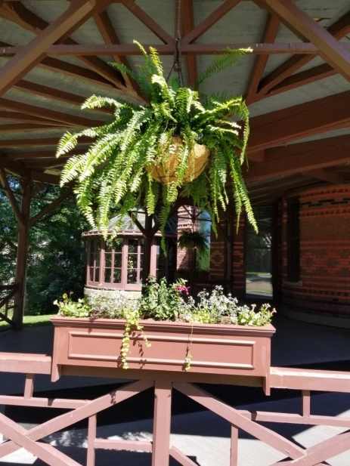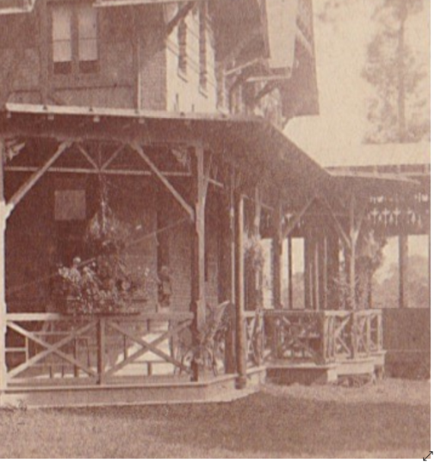

The Ombra Boxes

The boxes on the Ombra railings – seen at left above in July 2019, and at right at some time in the period 1874-81 -- are changed seasonally, once again using plants popular for such uses during the Clemenses’ era . Hardware cloth (wire mesh spaced widely enough to let plants grow through it) covering the soil keeps pesky squirrels at bay. Hanging plants visible in the early photographs are replicated in the ferns, so popular in Victorian times, that hang there today.

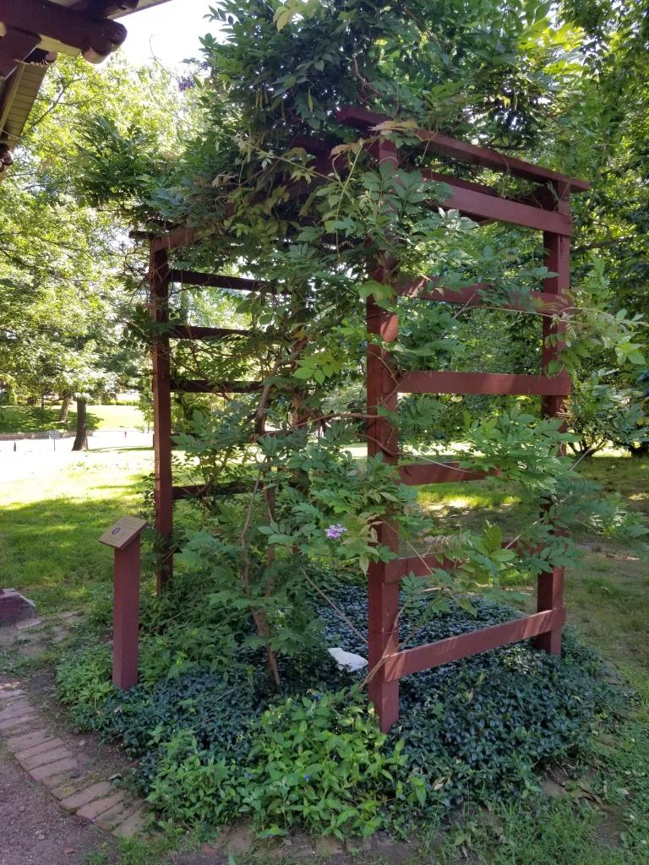

The Wisteria Trellis

The wisteria that has graced the front of the Mark Twain House since about 1920 is not contemporaneous with the Clemenses, but shows off its lavender hanging blossoms each spring. In 2016, after an older trellis blew down in a storm, scout Austin Bednarz built the new one as an Eagle Scout project. Periwinkle or vinca grow below the vineas a ground cover.

Thank you to our wonderful gardening volunteers: Gail and Ed Thibodeau, Cindy Curry, Sue Israel, and Rebecca Nisely.

2. THE CONSERVATORY

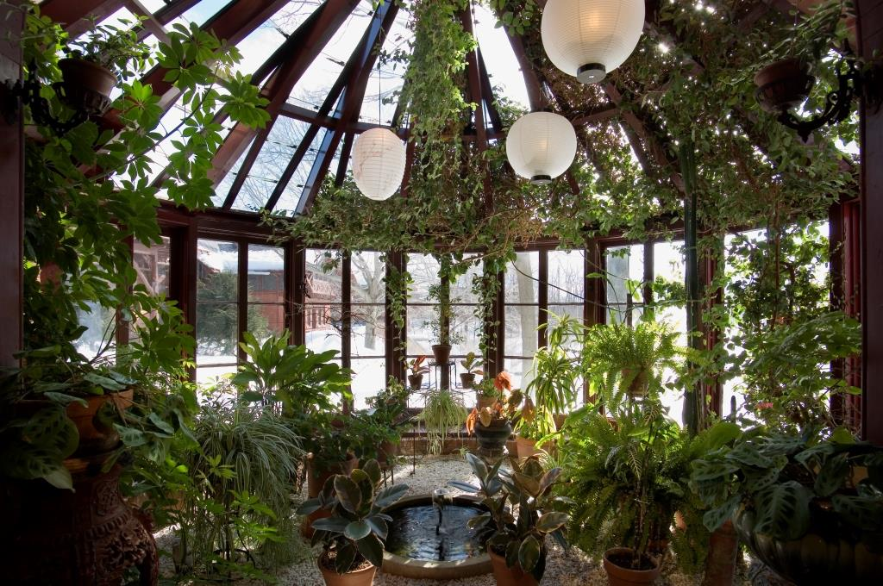
Master Gardener Marianne Cassidy arrived at the Mark Twain House in 2009, and immediately went to work to research the structure, learning not only about the plants used there but some of its construction – the white marble-chip floor, for example, and the constantly playing fountain. The conservatory was an important element of the Victorian picturesque architecture that inspired the house’s architect, Edward Tuckerman Potter. Some mid-20th century descriptions say that it was “of a type invented by Harriet Beecher Stowe.” Stowe Center Collections manager Elizabeth Burgess says it’s very possible that Stowe brought the idea back from her trips to England, and thus influenced the general architectural trends of the neighborhood, but she knows of no documented influence on the Clemens conservatory specifically.
Cassidy and her crew of Master Gardeners not only researched the plants that were there in the Clemens era, but also -carefully preserved and encouraged plants placed there by previous +gardeners, and replaced or added others. Its role as an indoor ecosystem must also be carefully monitored, and Marianne and her crew of Master Gardeners (see below) arrive quietly according to schedule, don their identifying badges, and go to work. Battles are fought and won against mealybug and plant diseases. In February, everything is removed and the whole area cleaned up. The following is a sampling of the Conservatory’s wonders.

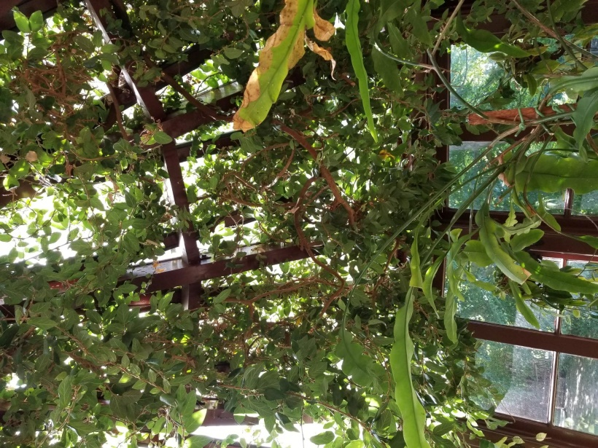
The star of the Conservatory is the creeping fig, often referred to as “Ficus” from its Latin name, Ficus pumila. One of those active in the 1960-74 restoration of the Mark Twain House was architect Robert Schutz, Jr., the grandson of the Clemenses’ family homeopathic physician, Cincinattus Taft (whose bearded visage sits on top of the piano in the drawing room) and his wife, Ellen C. Taft (whom Sam once bombarded with profanity over the phone, then blamed George). One day during the restoration era Schutz brought a horticultural treasure to the house: a cutting from a creeping fig from his own home. An ancestor of the cutting had been given to his grandparents by the Clemenses from their conservatory. It was planted in the Conservatory, a homecoming of sorts after nearly a century.
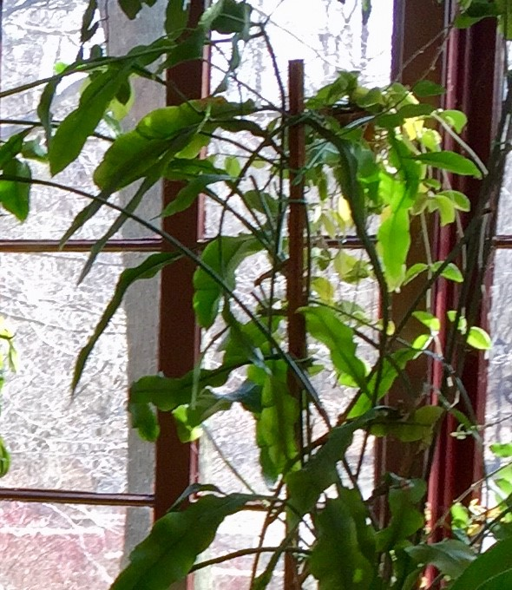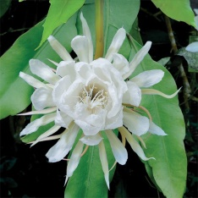
Above is another, more hidden star of the Conservatory – the night-blooming cereus, a spreading plant with crinkly-looking leaves. Every June this plant blossoms in the dark, an event that served as the occasion for midnight parties among the supporters of the Mark Twain House. These parties were essentially vigils, as it is hard to predict which night the night-blooming cereus will actually bloom, so the partying could go on for two or three nights.
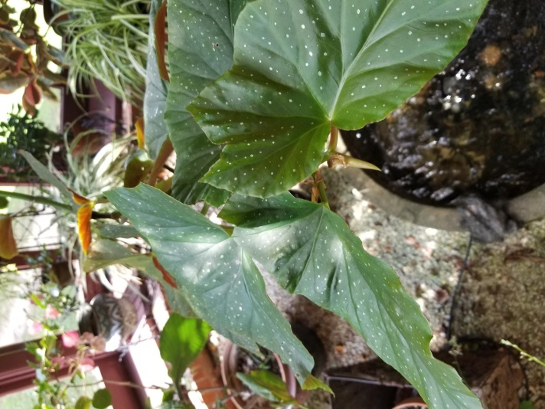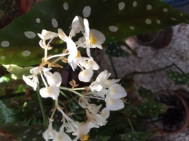
Victorian conservatory plants were often chosen for their variegated leaves – leaves with both green and non-green on them, in appealing and decorative patterns – as much as for their blooms. Among the numerous varieties of the begonia, with its origin in the tropics and redesigned over decades of hybridization, the showy angel wing begonia is a prime example.

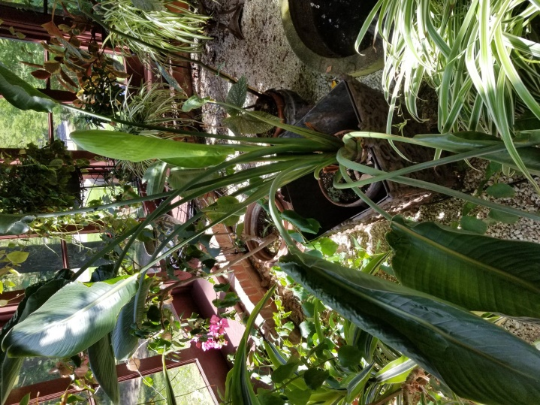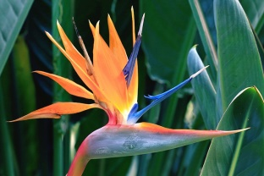
The Bird of Paradise comes from a plant native to North Africa, but the variety most cultivated in Victorian conservatories was named after a royal wedding with (for Americans) an unpatriotic twist. Its Latin name, Strelitzia reginiae, honors the marriage of King George III, the bane of American colonists, to Princess Charlotte of Mecklenburg-Strelitz in 1761. Its blossoms are truly birdlike, though, oddly, it’s a member of the same family as the banana.

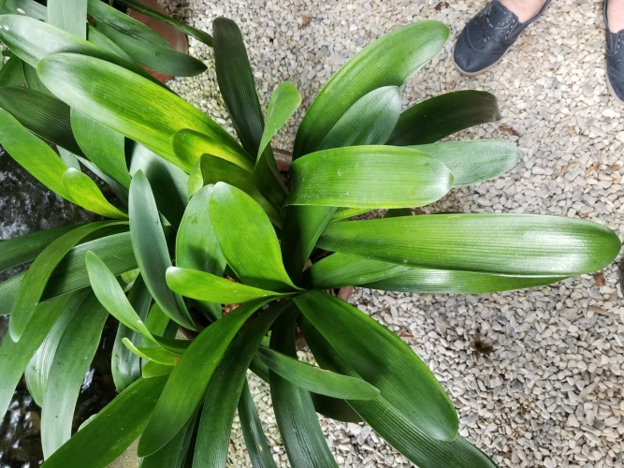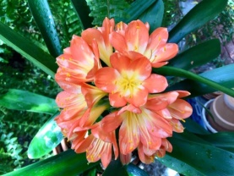
The clivia is another plant native to Africa – South Africa, in this case – where specimens were collected by British explorers in 1815 and 1820. Clivia also has a royal link: the Kew Gardens botanist William Burchell named it in honor of the governess of the future Queen Victoria, Charlotte Percy, Duchess of Northumberland, whose maiden name was Clive.

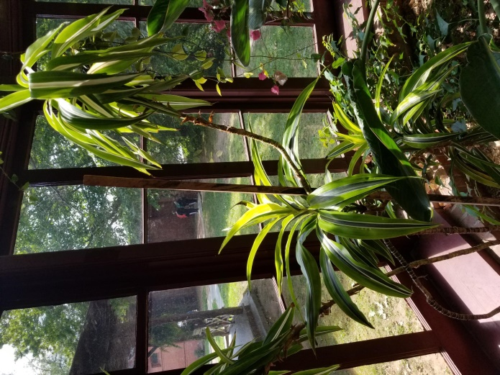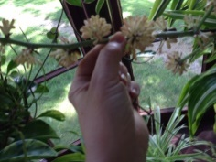
The corn plant is native to tropical Africa, where today it often shows up as a hedge plant. Sometimes simply called “dracaena,” from its Latin name, Dracaena fragrans, it has a reputation for removing toxins from the air, confirmed by a NASA study in 1989. The space agency was researching plants that might help purify the air in space stations.

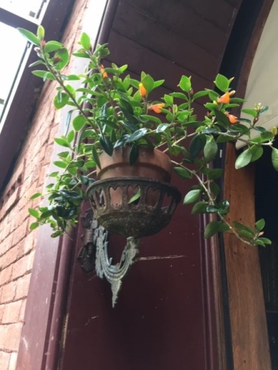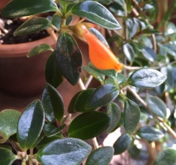
A photo taken of the Conservatory in 1896 (a mounted copy leans against the bookcase nearby) clearly shows cast-iron lamp brackets containing pots of the goldfish plant, which Marianne reports was a favorite of Livy’s. The name “goldfish” comes from the distinctive flowers, which look like fish swimming in a bowl of leaves and air.

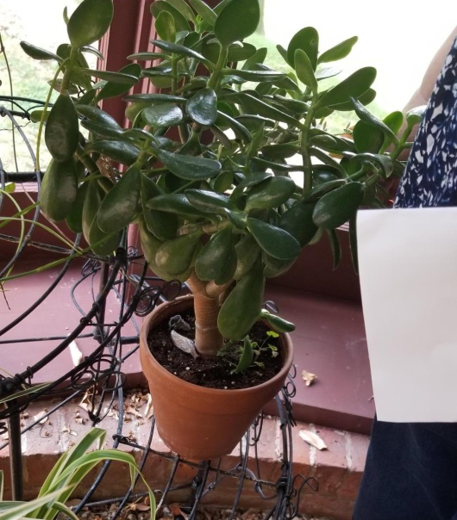
The jade plant, valued more for its visual appeal and addition of variety to the Conservatory than for its blooms, was another Victorian favorite. Its stolid green leaves evoke jade, the precious stone.

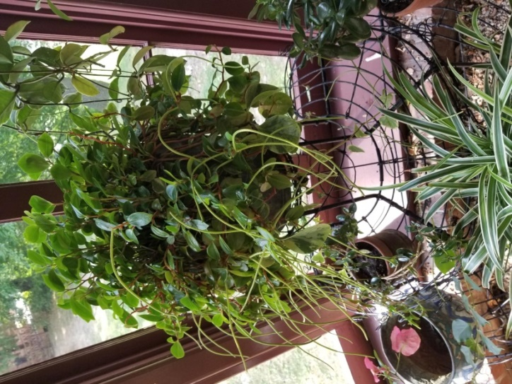
In the wild, peperomia grows in the Amazon region, under shady trees. It is valued in part for ease of maintenance, as “loving neglect” seems to work the best. The Conservatory container has mixed varieties of the plant.
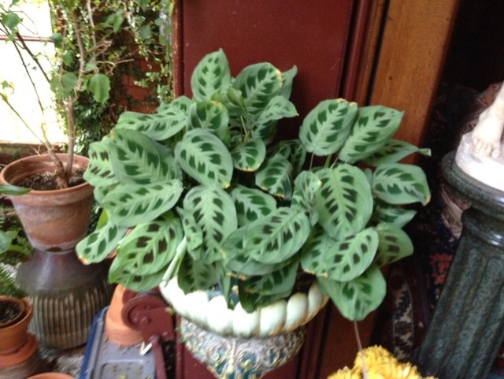

The prayer plant gets its name from its behavior as evening approaches: The leaves actually raise themselves up and fold like hands preparing for evening devotions.

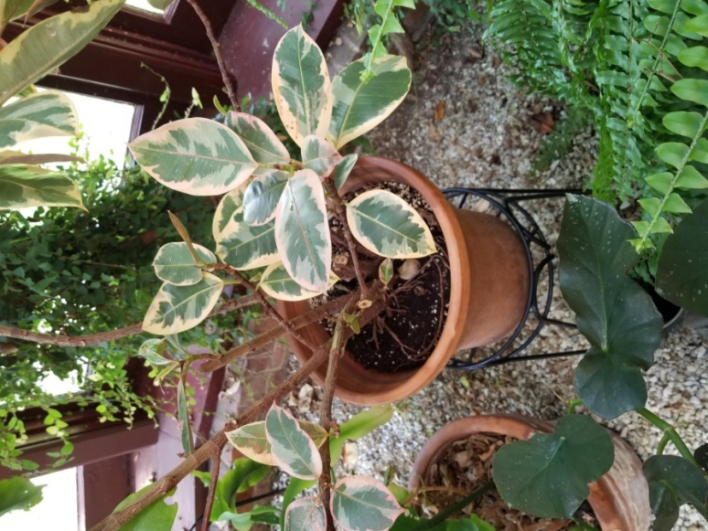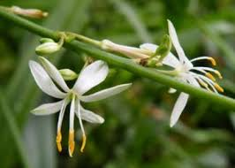
In India, the rubber tree can grow more than 100 feet high and develop roots that stand well above the ground. These roots are sometimes trained over ravines to form living bridges. Our Conservatory rubber tree is more ornamental, with its lovely variegated leaves.

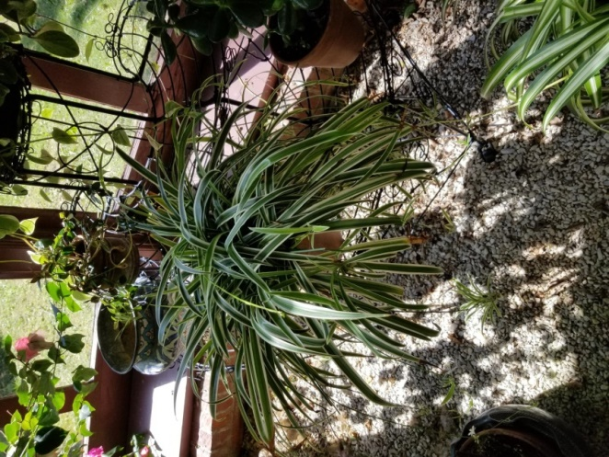
Anyone who owns a spider plant – we have several -- knows its habit of forming “offsets,” new plants complete with roots, at the ends of the stem of its flower. They hang there like so many – yes – spiders.

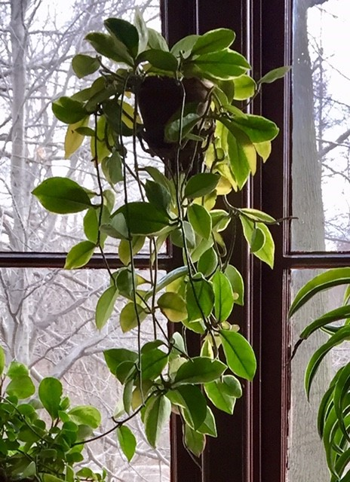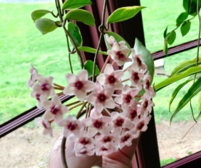
The wax plant, with its waxy leaves, is sometimes called “hoya” for its Latin name, Hoya carnosa. It has curving vines that send out star-shaped blooms that look like little sculptures; an alternate name is “porcelain plant.” It is native to Southeast Asia and Australia.

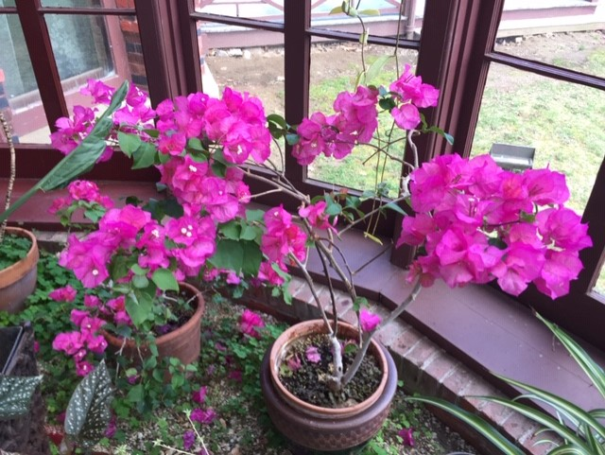

The showy bougainvillea, a South American plant, was brought to Europe in the early nineteenth century and quickly became a favorite of the English conservatories on which the Clemenses’ is modeled.
.
We want to thank Larry Zarbo, Mary Millican, and Helena Thompson for their longstanding and faithful work on the Conservatory.

